Chapter 1

**INTRODUCTION**

* 1. **What is LCC**

Nitrogen (N) fertilizer is important in rice production. Apply N fertilizer several times during the growing season to ensure that the crop's nitrogen need is supplied, particularly at critical growth stages. The Leaf Color Chart (LCC) is used to determine the N fertilizer needs of rice crops. LCC has four green strips, with color ranging from yellow green to dark green. It determines the greenness of the rice leaf, which indicates its N content [1]. Leaf Color Chart (LCC) is an instant, easy and low-cost technique for N diagnosis of current crop and N topdressing in crops. LCC an intelligent tool will help Rice. Maize & Wheat farmers to visually assess the need for nitrogen and apply the fertilizers. The color panels of the LCC are designed to indicate whether rice. maize. wheat plants are hungry or over-fed by nitrogen fertilizer. By matching the color of the rice. maize. wheat leaf to the color on the LCC. farmers can decide proper time and amount of N fertilizer for application. Leaf Color Chart ensure only need-based optimum use of chemicals in agriculture. Chemical fertilizer particularly urea is having indiscriminately applied to rice. maize and wheat in intrusively cultivated regions. There is an urgent need to rationalize the use of urea and other nitrogenous fertilizer (organic and inorganic) in a way that these are applied as per the need of the crop by using LCC. [2]

* 1. **Advantages of LCC**
* Better Crops
* Avoid Diseases
* Fertilizer at Right Quantity at Right Time when Crops needs
* Save Money for Farmers o Huge subsidy savings on N fertilizer for Govt.
* Reduces GHG Emission

The use of LCC in Punjab state in India. recommended by the Punjab Agricultural University for maize. rice and wheat crops. can result in saving of Rs 170 crore (38 Million USD) annually as well as the environment [2]

* 1. **Why LCC**

With the use of LCC in irrigated rice. let us assume a potential saving of 23 kg N or 50 kg urea per ha per season. The calculated annual savings of urea are provided in the table below for selected Asian countries (except China). The estimated annual saving of urea is 834.000 tons for India if 50% of farmers use LCC in the irrigated rice area of 22.3 million ha.

Other countries that could save substantial amounts of urea when they adopt LCC are Indonesia. Vietnam. Bangladesh and the Philippines. For the whole of Asia. except China. the potential annual saving of urea is estimated at 1. 2. 3 and 4 million tons. respectively. with 25. 50. 75 and 100% of farmers using LCC in irrigated rice. [2]

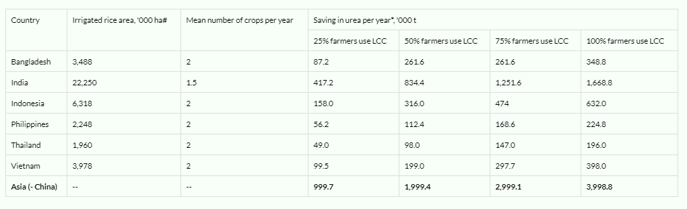

Figure 1.1: Saving urea using LCC

* 1. **Problem Statement**

LCC is a discrete system. Not a continuous system. Some time farmer can not detect the correct label for leaf for this farmer does not get the expected result. Ph diverse from the optimal Ph. Over fertilization causes high cost under fertilization cause low yield.

* 1. **Motivation**

Bangladesh is agriculture-based county. Though Digital Bangladesh was declared but our farmer uses fertilization manually. Some farmer does not use LCC at all. But most of the people has smart phone. They can use their smart phone camera for capture image for fertilization. For this reason, I have developed this system.

* 1. **Contribution Summary**

Our main objectives are to develop a system which will solve our problems and fulfill all our challenges. So, we need some features into our system which are given below:

* Paddy fertilizer monitoring system.
* Auto notify the farmer for fertilization
* Auto segmentation.
* Online and Offline mode. (Because some farmer does not have internet on their smart phone)

Chapter 2

**PRELIMINARIES**

**2.1 Notation and Equations**

**Color NET (Online Mode)** - Our CNN architecture consists 2 base networks and 8 layers for each base network with total 16 layers. The first two layers of our CNN architecture is a convlutional layer and it does convolution process following by normalization and pooling. Convolutional layer is a layer that do convolution process that same as convolution process in image processing algorithm. For Ii is an input image and h is a some convolution kernel, output image for convolution process Io can be written as [3]



with [m, n] is pixel value at coordinate (m, n). Training process of CNN will learn h, may called as kernel, as parameters of convolutional layer. The choice of activation function in convolutional layer have huge impact for the networks. There a several choice of activation function including tanh and ReLU (Rectified Linear Unit). In our CNN networks we use ReLU activation function for all layers including the fully-connected layers. The normalization process done by following equation 2 with α = 10−4 , β = 0.75, and n = 5. [3]



**Decision tree classifier (Offline Mode)** - Entropy is degree of randomness of elements or in other words it is measure of impurity. Mathematically, it can be calculated with the help of probability of the items as [4]:

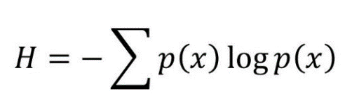

p(x) is probability of item x.

It is negative summation of probability times the log of probability of item x. [4]

**2.2 Solution of Current Problems**

* Automatic segmentation
* Automatic label detection
* Works on offline and online mode
* Paddy field monitoring
* Notifying farmer about fertilization
* No need of white paper
* Easy to use
* No need to carry LCC
* If farmer has eye problem smart phone will auto detect label

**2.3 Literature Review**

This chapter were providing the theoretical background which is related to the project development and make reference to existence of other systems

**2.3.1 Assessment of Color Levels in Leaf Color Chart Using Smartphone Camera with Relative Calibration**

Yuita Arum Sari, R V Hari Ginardi, Riyanarto Sarno, Leaf Color Chart (LCC) is used in agriculture modeling for monitoring the plant performance by comparing the leaf color and its corresponding color in LCC. To digitize the acquisition and interpretation of leaf color, smartphone camera is used. A color calibration is necessary for a smartphone before it can be used to capture and interpret leaf color. The calibration process evaluates the camera performance with the operational lighting conditions and determine whether the smartphone camera can be used for leaf color interpretation or not. The result from camera color calibration is used as a relative color chart for interpreting leaf color. In this paper, we propose a method of relative color calibration, which makes the system, learns colors chart automatically without depending on specific standard colors. KNearest-Neighbor (KNN) classification is used for color learning process in RGB color space. Our method is successfully tested with two smartphone devices in different lighting condition. The test shows an average accuracy above the threshold value of 83%. [5]

* Doesn’t uses segmentation
* Doesn’t uses real leaf
* Low accuracy

**2.3.2 Android Based Mobile Application to Estimate Nitrogen Content in Rice Crop**

Navdeep Kaur, Derminder Singh, The color of leaf corresponds to nitrogen deficiency status of that particular crop, farmers compares color of leaf with Leaf Color Chart (LCC) in order to estimate the need of nitrogen fertilizer of their crop. However the ability to compare leaf color with the LCC varies from person to person that affects the accuracy of final result. This paper proposes a mobile-device based application called "mlcc". Main idea is to simultaneously capture and process a 2-D color image of rice leaf, thus eliminating the expensive external components, reducing the human color perception and results in achieving high color accuracy. This android-based application can be correctly identified all the important 6 green color levels of rice leaf. [6]

* Segmentation needs a paper not automatic
* Doesn’t has any solve for different day light condition

**2.3.3 Automatic Leaf Color Level Determination for Need Based Fertilizer using Fuzzy Logic on Mobile Application**

Kestrilia R. Prilianti,Samuel P. Yuwono,Marcelinus A.S. Adhiwibawa,Monika N.P. Prihastyanti,Leenawaty Limantara,Tatas H.P. Brotosudarmo, Detecting plant nutrient deficiencies and evaluating fertilizer program are done by leaf tissue analysis. Unfortunately, this quantitative method is quite expensive and time consuming for traditional farmers due to its laboratory procedure. In this research, an automatic and nondestructive method based on digital image for soybean leaf color level determination was developed. Color level status is used to determine the fertilizer dose based on crops current need. The color level was adopted from 4-panel Leaf Color Chart (LCC) and a fuzzy logic model was applied to capture the leaf color gradation. Therefore, the leaf color status is not restricted only in 4 categories, but gradually change from light yellow up to dark green. Using this mechanism the N fertilizer dose will also gradually adjust. Hence, the N fertilizer could be used efficiently and in the same time prevent the environment from negative effects of fertilizer overuse. The method was embedded in a mobile application to facilitate real time field application. Hence, detection of soybean nutrient deficiencies and fertilizer program evaluation will need less time and low cost. From the field test, it was known that the mobile application could determine the soybean color level correctly. 100% accuracy in test condition. [7]

* Segmentation needs paper
* Day light change problem

**2.3.4 Nitrogen (N) Fertilizer Measuring Instrument On Maize-Based Plant Microcontroller**

Abstract—One of the growth factors of corn plant is fertilizer according to nitrogen fertilizer requirement. The identification of nitrogen fertilizer requirement in corn plant can be done by measuring the green leaf level using Color Leaf Manual, using TCS3200 color sensor combined with Arduino Uno Board microcontroller, and information. In this study a tool was created that could automatically measure the amount of fertilizer needed for corn per hectare. The results of the measurements displayed on the LCD 2x16 bits Micro made a measurement of fertilizer based on leaf color for corn plants. By taking the RGB value from the leaf that comes through the color sensor and then compared with the RGB value in the leaf color chart that has been saved in microcontroller will get the information of the fertilizer dosage needed. The level of truth of the measuring instrument of fertilizer can be categorized good enough with the level of accuracy reached 82%. [8]

* Needs external device
* Complex for farmer
* Daylight change problem

**2.3.5 Automated Color Prediction of Paddy Crop Leaf using Image Processing**

Amandeep Singh,Maninder Lal Singh, In India a majority of the population in rural areas is working in the agriculture field for their livelihood. They not only have to struggle for the better yield against the natural disasters but also have to tackle the losses of the net output because of land fertilization specifications and unskilled labor too. In the event of inadequate utilities and resources, in the face of unpredictable crises, their gain opportunities and livelihood are proportionally and adversely affected. However in this era of technology, the scenario may get changed as the Information and Communication and related fields of technology are providing a great for such type of crisis handling. Here in this paper, the method which may be used to compare the crop leaf color with the leaf color chart (LCC), has been proposed for getting a detail about the requirement of plant, before enough to get the yield affected. By making use of image processing technology a simple and robust method for the color prediction of paddy crop plant has been discussed along with the mathematical modeling which may provide a great platform to the advisory bodies in the agriculture field for the atomization of the crop health problems and solutions. [9]

* Needs white paper for segmentation
* Hard to implement on the smart phone
* Day light change problems

Chapter 3

**PROPOSED WORK (DIGITAL LCC)**

**3.1 Overall system**

Overall system of Digital LCC.

Cloud

Cloud

Farmer

 Smart Device

 Delusion Tree

 Average RGB

Simple Segmentation

 Result

Complex segmentation

Cloud Processing

 Keras Model

 Result

Figure 3.1: Overview of Digital LCC

**3.2 Dataflow Diagram**

Dataflow diagram of Digital LCC.

.

Cloud

Field Area

Field Area

Offline

Avg Green

Avg Red

Avg Blue

Time

Tine

Rect area

Decision tree depth 5

70% Green Shade

120*80*4 Array

Farmer

Input

Output Fertilizer

Online

Leaf on hand Image

Input

Send to Cloud

Segmentation

Feed in Keras model

Predict the closest label

Input and label calculation

Output fertilizer

Figure 3.2:Dataflow diagram of Digital LCC

**3.3 Ideal Data**

Ideal data was capture using Webcam (Logitech C920). The webcam has stand on a tripod for capturing data. Webcam captured data at different lighting condition in shade from 9AM to 1:30PM.

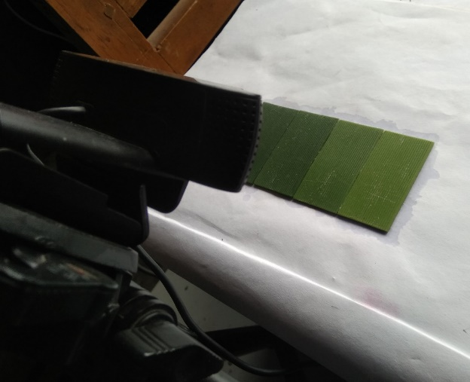

Figure 3.3:Ideal data collection using webcam

Code used for capturing image:

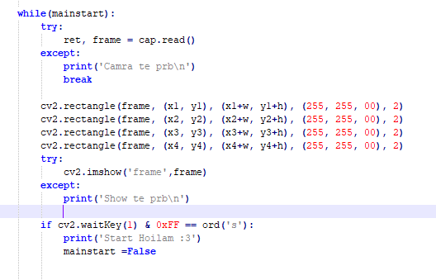

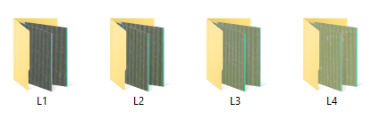

Figure 3.4: Ideal data sets

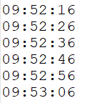

Figure 3.5: Ideal data sets time

**3.4 Data Collection (Paddy Fields)**

Capturing leaf image using smart phone (Samsung Galaxy Note 5, Samsung J7, Symphony P7) in the field and writing note of label matching LCC manually.

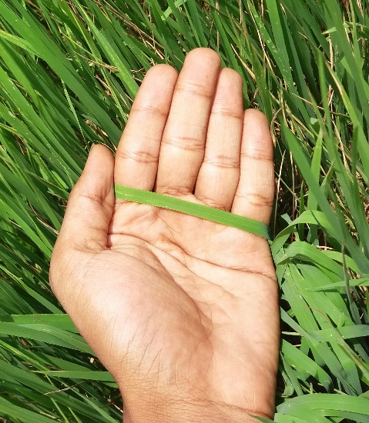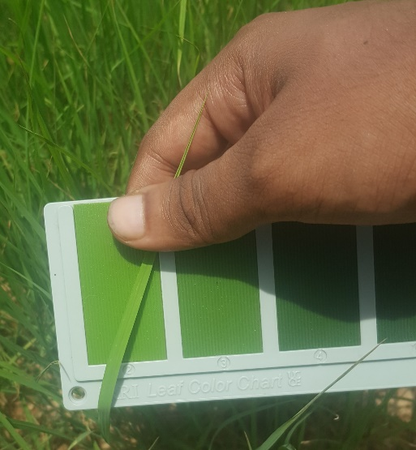

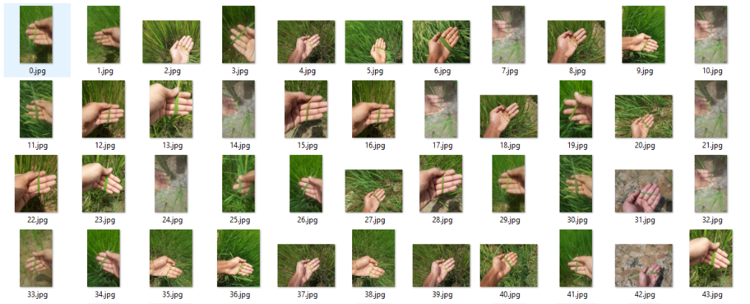

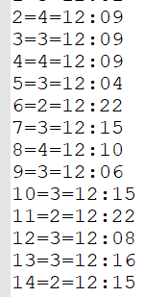

Figure 3.6: Paddy field data collection with time

Total 150 image was captured for testing without LCC in the image with capture time.

**3.5 Offline Mode**

When farmer is offline, they will use offline mode. It is having low accuracy but works well if more image is taken. But it has manual segmentation system. Leaf must be on the rectangle area.

Rectangle area

Image

HSV Green Image

Input area

Output fertilizer

Check 70% > Green color

Predict

Decision Tree

Figure 3.7: Overall offline mode

**3.5.1 Decision Tree Classifier**

Making a CSV file with time and making the average of red, green and blue.

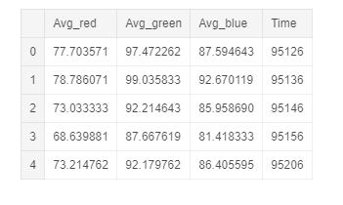

Figure 3.8:CSV file with AVG (Red, Green,Blue) and Time

Creating decision tree classifier.

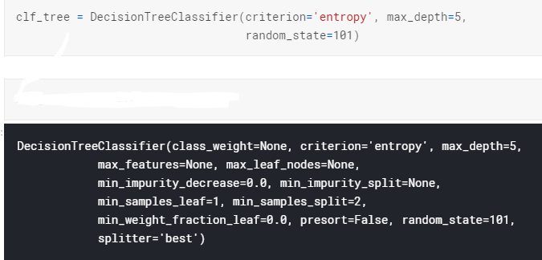

Figure 3.9: Decision tree creation

Overview of decision tree.

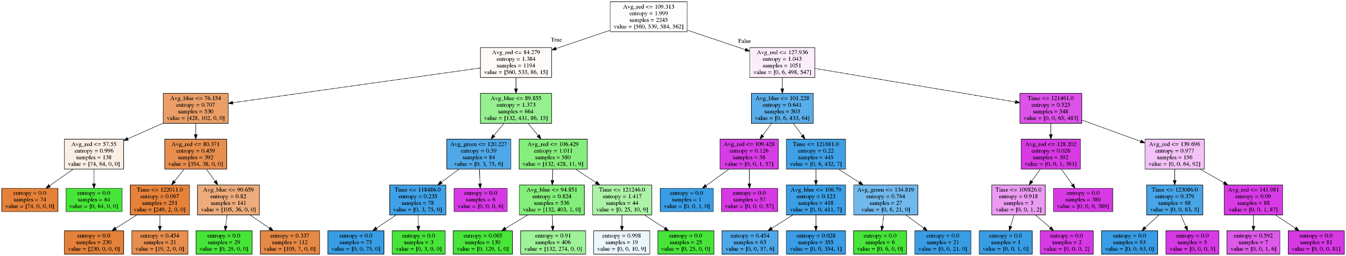

Figure 3.10: Decision tree graph

Accuracy of decision tree

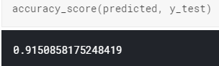

Figure 3.11: Accuracy of Decision tree

Confusions matrix of decision tree classifier

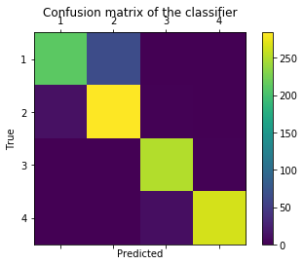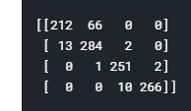

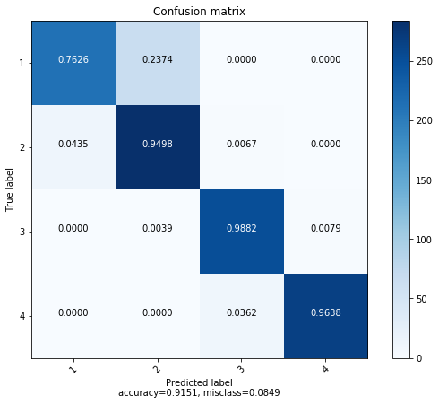

Figure 3.11.1: Confusion Matrix

**3.6 Online Mode**

If farmer has internet it will be in online mode. Then the farmer will take picture keeping the leaf on the hand. Then the app will segment the leaf according to it.

**3.6.1 Segmentation**

When the farmer take picture keeping leaf on hand smart device will segment out the leaf from hand.

Full Image with hand

Convert to HSV in skin color range

Detect contour

Find the leaf with 2nd biggest contour

and mask the image

Output only leaf

Draw convex hull

Range the green shade

Segment the convex hull and musk the image

Figure 3.12: Segmentation overview

Segmentation process

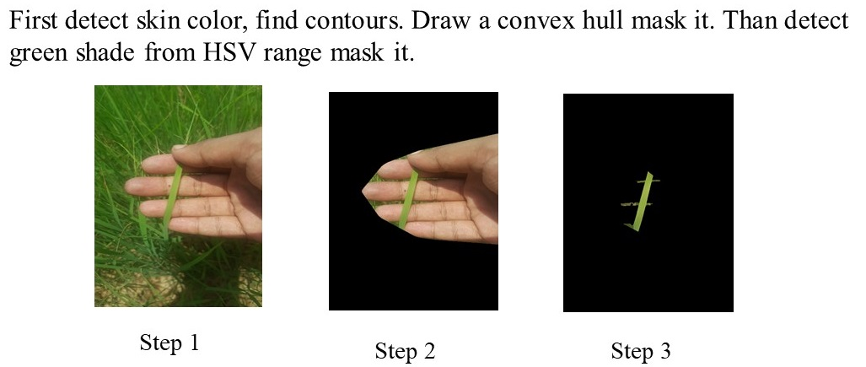

Figure 3.13: Segmentation process

**3.6.2 Color Net (CNN Model)**

Convolution model is using exiting color net model [3]

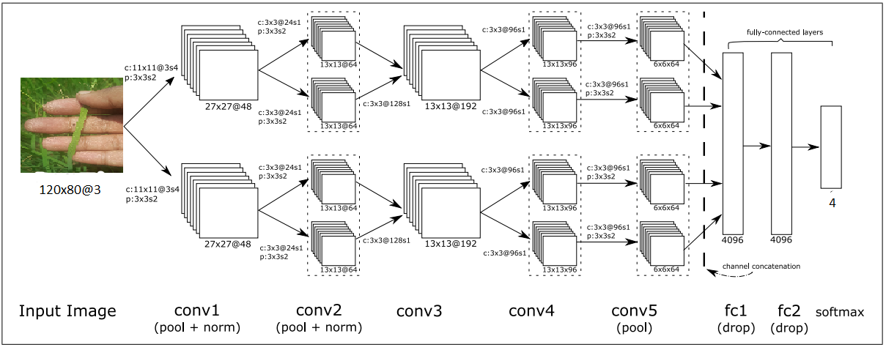

Figure 3.14: Color net model

Training the Color net model with our ideal data for leering the color of different labels at different lighting condition and different time.

Learning 30 Epochs

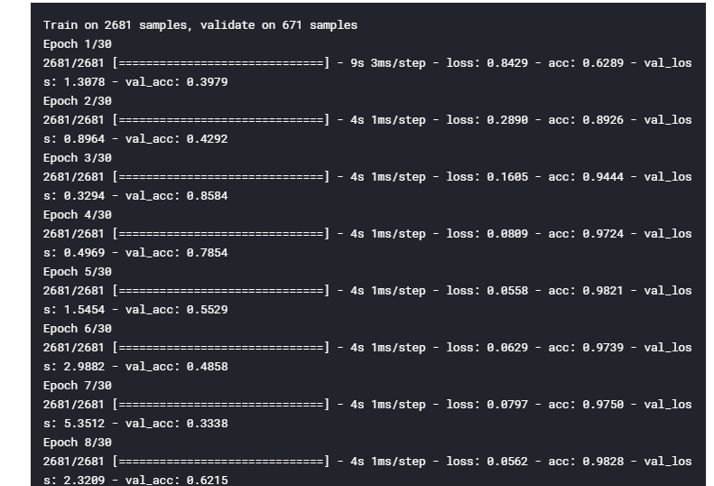

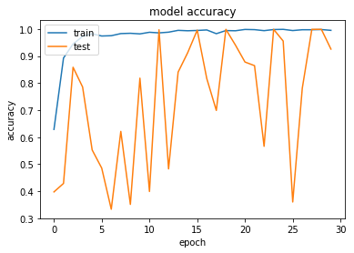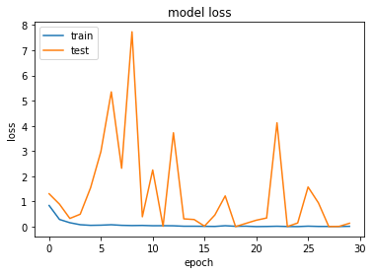

Figure 3.15: Per epochs history

At epoch 24 we get higher validation accuracy. Almost 100% accuracy.

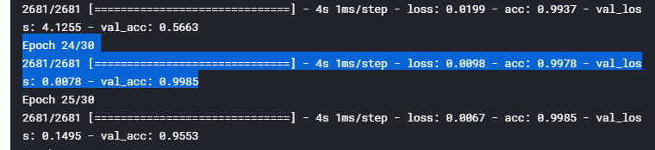

Figure 3.16: Accuracy of the model

Full overview of the model

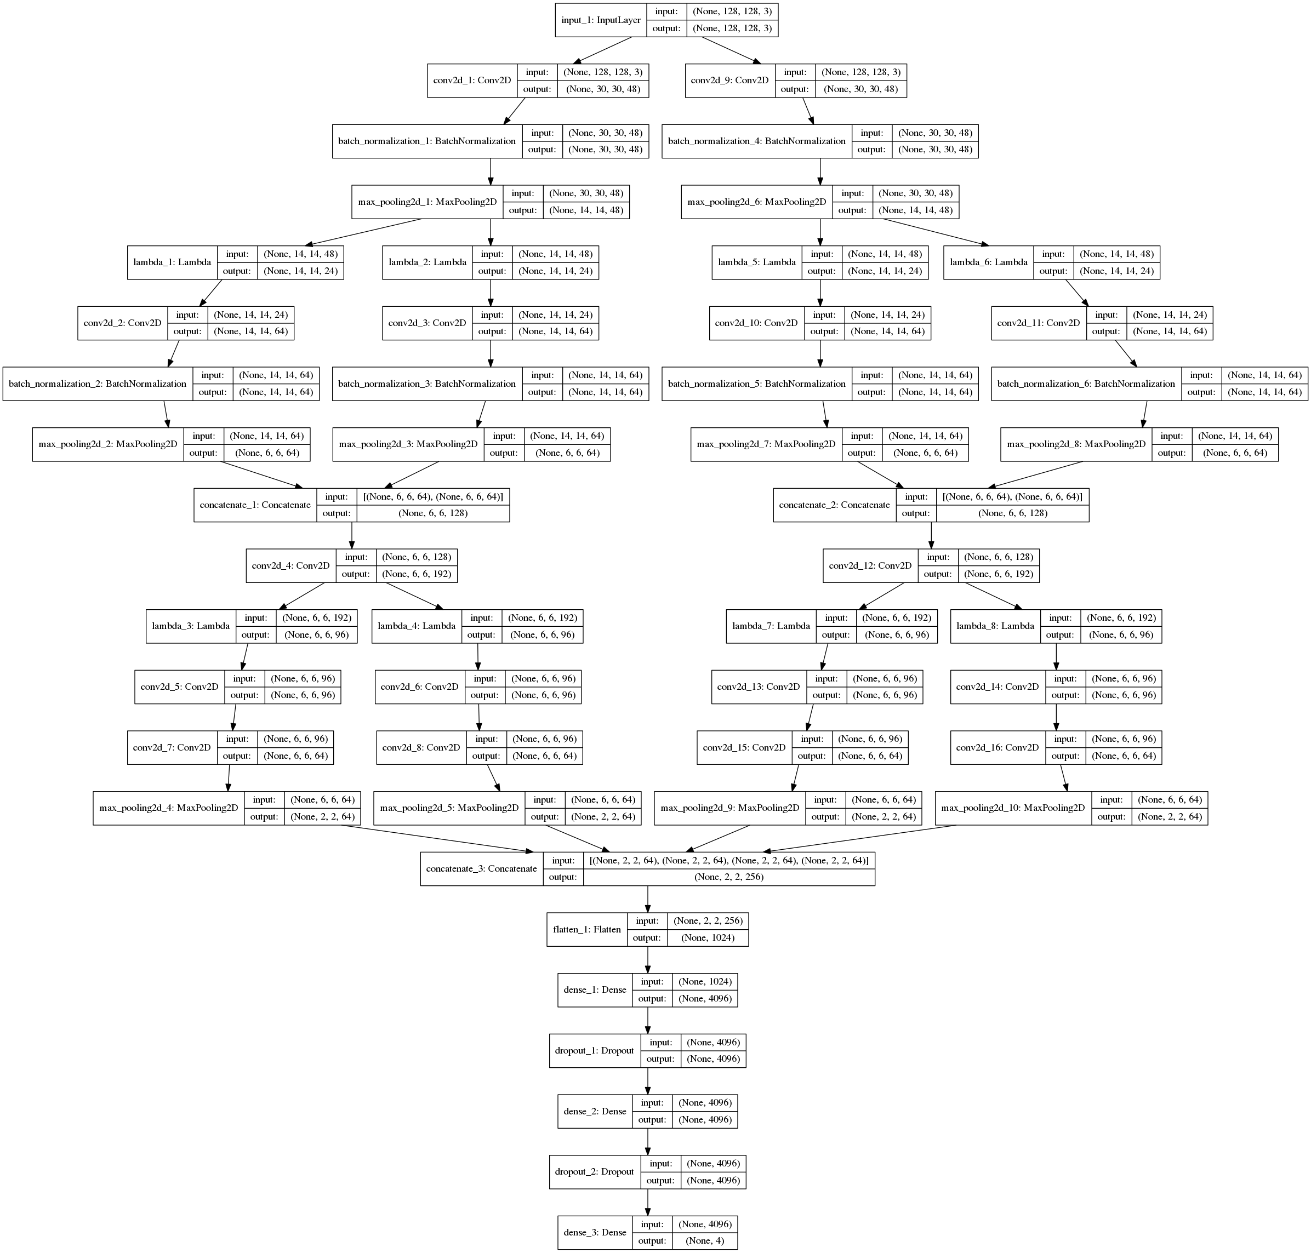

Figure 3.17: Full layers of the Color net model

Application using API data flow

Leaf on hand

API call to server

Segmentation

Input paddy field area

Output fertilizer amount

High performance computer

Send result

Run Keras model

Figure 3.17: Data flow diagram

Chapter 4

**CONCLUTION**

**4.1 Conclusions**

I have developed this system for automation the whole process of LCC. This system is for rural area farmers. This system will tell the farmer if the leaf is far distance from the camera (by 70% > green range). Farmer doesn’t need paper for using this system. If the farmer is online the segmentation process is much simpler, farmer can just take image of leaf on the hand. By this system paddy field is monitored automatically.

**4.2 Drawbacks**

There is some drawback of my system

* Offline mode is not so accurate
* Two individual mode
* No app is made just the system is developed
* Farmer have to capture the image in shade not in full sun light
* Offline mode segmentation mode needs some adjustment

**4.3 Future Works**

This system can be further more improved. There are some improvements are given below

* Making the whole system offline
* Using Tensorflow Lite we can make the whole system offline
* We can make the segmentation process much faster by using Mask CNN Net
* Mobile app with good user interface
* In app assistant for using it properly
* Convert the whole model in Plat buff for mobile device
* Making this system for other crop fields